Project Design Phase-II
Data Flow Diagram & User Stories

Date | 18 june 2026
Team ID
Project Name | SHOPEZ – E-Commerce Web Application
Maximum Marks | 4 Marks

Data Flow Diagrams:
A Data Flow Diagram (DFD) is a traditional visual representation of the information flows within a system. A neat and clear DFD can depict the right amount of the system requirement graphically. It shows how data enters and leaves the system, what changes the information, and where data is stored.
DFD Level 0
(Simplified) FLOW
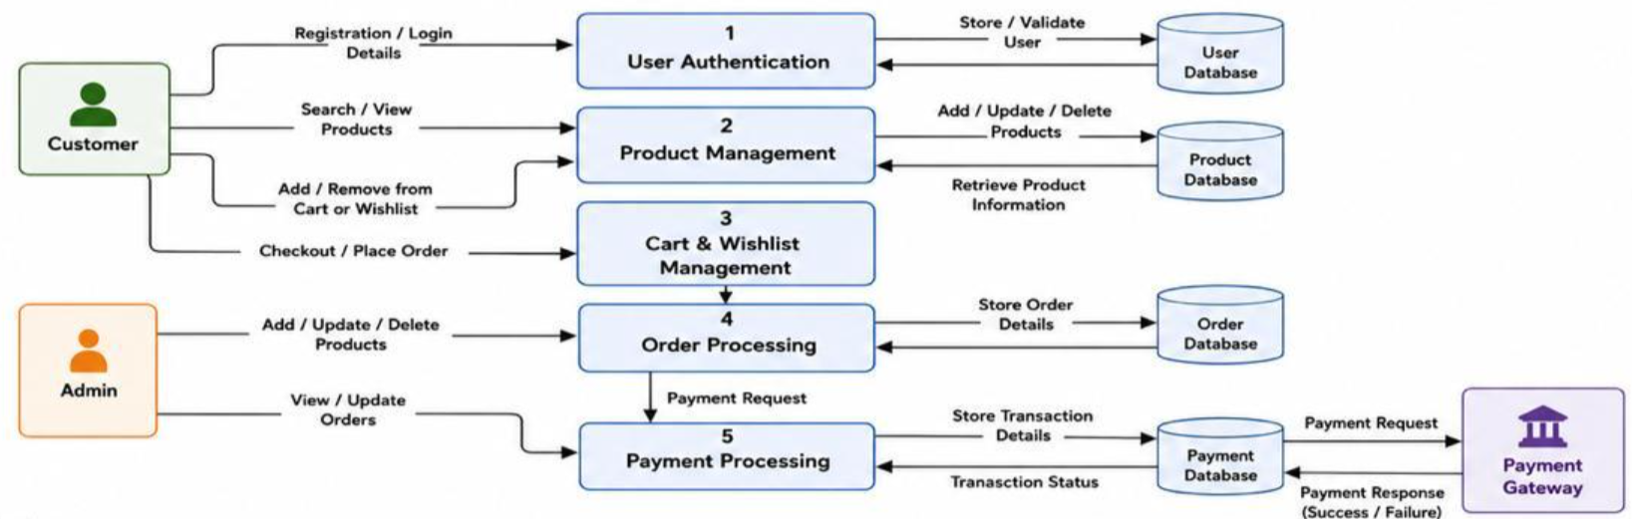
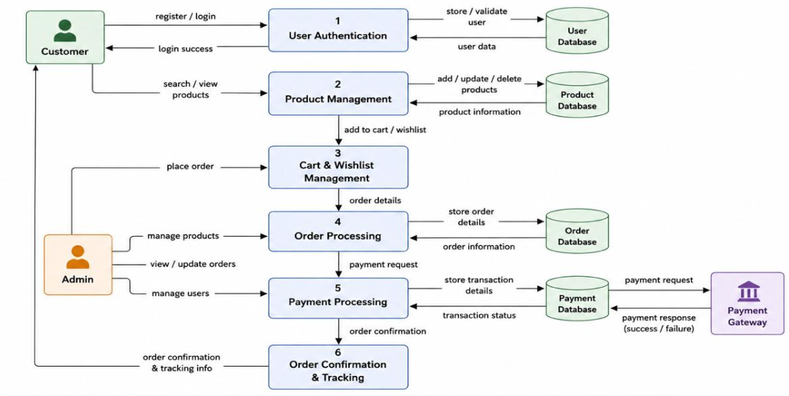

USER STORIES
User Type | Functional Requirement (Epic) | User Story No | User Story / Task | Acceptance Criteria | Priority | Release
Customer | Registration | USN-1 | As a customer, I can register using email and password. | Account created successfully. | High | Sprint-1
Customer | Login | USN-2 | As a customer, I can log in using registered credentials. | Dashboard opens after login. | High | Sprint-1
Customer | Product Browsing | USN-3 | As a customer, I can browse available products. | Products are displayed correctly. | High | Sprint-1
Customer | Product Search | USN-4 | As a customer, I can search products by name/category. | Relevant products are displayed. | High | Sprint-1
Customer | Product Details | USN-5 | As a customer, I can view detailed product information. | Product page displays description, price and image. | High | Sprint-1
Customer | Cart Management | USN-6 | As a customer, I can add products to my cart. | Selected product appears in cart. | High | Sprint-2
Customer | Wishlist | USN-7 | As a customer, I can save products to wishlist. | Wishlist updates successfully. | Medium | Sprint-2
Customer | Checkout | USN-8 | As a customer, I can place orders through checkout. | Order is created successfully. | High | Sprint-2
Customer | Payment | USN-9 | As a customer, I can make secure online payments. | Payment is completed successfully. | High | Sprint-3
Customer | Order Tracking | USN-10 | As a customer, I can view my order history and status. | Order details are visible. | Medium | Sprint-3
Admin | Product Management | USN-11 | As an admin, I can add new products. | Product appears in catalog. | High | Sprint-1
Admin | Product Management | USN-12 | As an admin, I can edit product details. | Updated details are saved. | High | Sprint-2
Admin | Product Management | USN-13 | As an admin, I can delete products. | Product removed from catalog. | Medium | Sprint-2
Admin | Order Management | USN-14 | As an admin, I can manage customer orders. | Order status updates successfully. | High | Sprint-3
Admin | User Management | USN-15 | As an admin, I can view registered users. | User list is displayed. | Medium | Sprint-3

